

Accessibility Guide for Coombe Country Park
coombe.countrypark@coventry.gov.uk, 02476 453720, www.coventry.gov.uk/coombe
Contact for accessibility enquiries: Please contact the park with any enquiries.
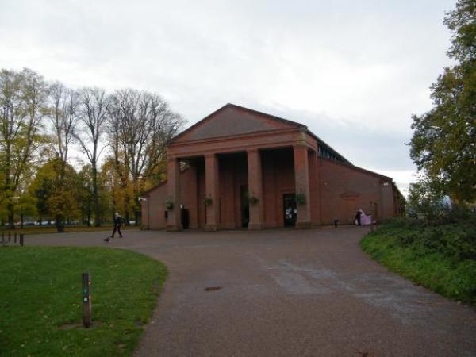

Welcome
Coombe Country Park is an ideal setting for a quiet little picnic or a fun family day out. With its 500 acres of beautiful gardens, lakeside walks and woodland it is ideal for everyone. From the diverse 'Capability' Brown landscape to the SSSI nature areas the park offers something for families, wildlife enthusiasts or even those just out for a quiet stroll though the wild flower meadows or woodland.

At a Glance

Level Access
- There is level access from the main entrance to:
  - Dining Table
  - Information desk
  - Accessible toilet and baby change
  - Gift shop
  - Formal gardens and woodland areas
  - Bird Hide
  - Top Pool Lodge Toilets
- There is level access from the car park to:
  - we have varied picnic areas
- We have a viewing area for wheelchair users.

Hearing
- The fire alarm has flashing lights.
- We have a hearing loop in A Hearing loop is available in the Information centre. and Wheelchairs are available on a deposit basis..
- Some staff have disability awareness training.

Visual
- The menu is in large print.

General
- There is at least 1 public toilet for disabled visitors.
- Some staff have disability awareness training.

Getting here
Brinklow Road
Coventry
West Midlands
CV3 2AB

Travel by public transport
- You can get to Coombe Country Park by bus and train.
- The bus stops at the top of the drive on the Brinklow Road. There is no Bus stop signage or shelter however all drivers are aware that they stop at the park and Hotel. If you are travelling from the Rugby direction towards Coventry you will need to cross the busy Brinklow road. The 585 bus travels from Coventry Railway station to Coombe Country park. Coventry Railway station is approximately 6 miles / 942.8 km from the Park. There is taxi rank outside of the station and the 585 bus stop is just to the Right as you exit the station. The bus stop is 0.40 miles / 942.8 km from Coombe Country Park.
- The nearest train station is Coventry Train Station. The train station is 6 miles / 9.7 km from Coombe Country Park.
- You can get a taxi with Allens Taxi by calling 02476 555 555. The taxi company has a wheelchair accessible vehicle.

Parking
- We have a car park. There are accessible parking spaces. Parking is not free.
- There is a drop-off point at the main entrance. The drop-off point has a dropped kerb.
- From the car park to the entrance, there is level access. The route is 150mm wide, or more.
- The main car park is the first car park on the right hand side of the drive. There are car parking charges for all vehicles including concessionary charges for blue badge holders. Please see our web site for up to date car parking charges.The car park is hard standing with uneaven surfaces but is accessible to wheelchair users with assistance.
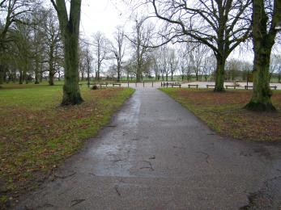
Footpath from the car park to the main drive.
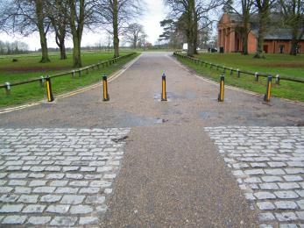
Footpath from drive to Visitor centre

Arrival

Path to main entrance
- From the street to the main entrance, there is level access.
- The path is 150mm wide, or more.

Main entrance
- The main entrance has level access.
- There are identical entrances at both ends of the Vistor centre with no doors on either end.
There is a very slight level change to acces the Visitor Centre.
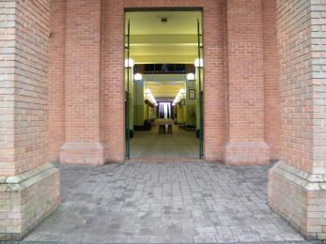
Entrance to visitor centre
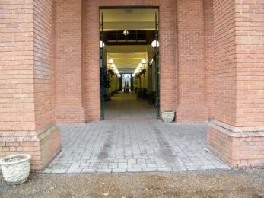
North end entrance to visitor centre

Getting around inside

Ticket/ information desk

Information desk
- From the main entrance to the desk, there is level access. The route is 850mm wide, or more.
- The door is 850mm wide, or more.
- The desk has a low section.
- The information desk can be accessed directly from the main entrance of the Visitor centre. The information desk has information about the park and access inforamtion can be obtained there. There is plenty of room within the information centre to manouver wheelchairs or large pushchairs.
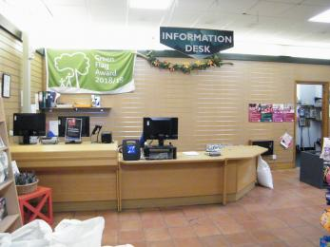
Information desk
- From the main entrance to this area, there is level access. The route is 2mm wide, or more. The door is 800mm wide.
- Some display information is low, for wheelchair users. There is a hearing loop.

Spectator/ Audience viewing areas
- We have a viewing area for wheelchair users.

Public toilet

Accessible toilet and baby change
- There is a public toilet for disabled visitors.
- You need a RADAR key to open the public toilet.
- From the main entrance to the public toilet, there is level access. The route is 2mm wide, or more.
- The toilet door is 850mm wide.
- The direction of transfer onto the toilet is to the left.
- There is 1150mm at the side of the toilet. There is 1150mm in front of the toilet. The toilets have handrails.
- There are drop down handrails on the transfere side of the toilet with the toilet flush also on the transfer side. Toilet roll dispenser can be reached from the seated possition but the sink can not.
There are also baby change facilites within the accessable toilet and once extended this is 90cm into the toilet transfere space.
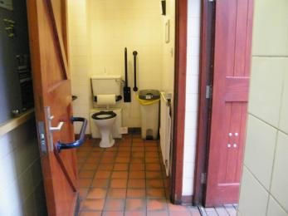
accessible toilet in visitor centre

Shop

Gift shop
- From the main entrance to the shop, there is level access. The route is 2500mm wide, or more. The door is 850mm wide.
- The route through the shop is 800mm wide, or more.
- The shop contains a variety of gifts and souvenirs for your trip. Gifts are shown at different levels. The floor surface is non-slip tiles and there is plenty of room to manoever wheelchairs and pushchairs.There is also a hearing assistance loop in the shop and information cnetre.
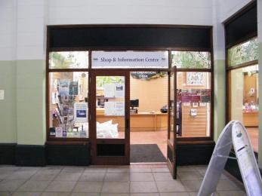
Shop and information centre

Place to eat and drink

Cafe in the Park
- From the main entrance to the dining area, there is level access. The route is 2500mm wide, or more. The door is 850mm wide.
- To get to a table, there are no steps.
- The menu is offered in large print.
- If you need table service, staff can help you.
- The route through the dining area is 800mm wide, or more.
- There is background music sometimes.
- The table and plates have high colour contrast.
- We cater for sugar free (diabetic), vegetarian, gluten free (celiacs), lactose free (dairy free), nut free, low fat, high fibre and vegan specific diets.
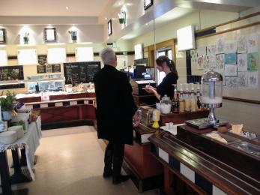
Cafe service area
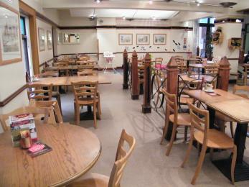
Cafe seating area

Getting around outside

Formal gardens and woodland areas
- From the main entrance to the gardens, there is level access.
- There is a permanent ramp.
- The route is sloped. The route is 2500mm wide, or more.
- The gardens and woodland walks are signposted and trail information can be found on our information leaflet. The majority of the footpaths are wheelchair and pushchair freindly.
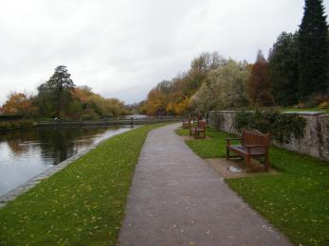
Moat walk
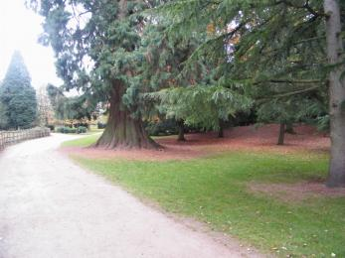
Formal gardens
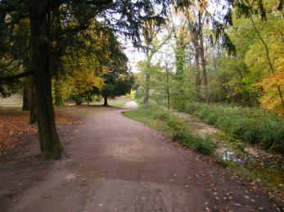
Riverside path

Designated Walking Trail

Nature trails
- The trail is 3000metres long. Some of the trail has a loose surface. The trail is sloped. The trail has seats.
- The park has a variety of trails with different distances, path types and terraine. All the trails are clearly sign posted and information can be found on our information sheet which shows each of the trails as a different colour. Seating is availble along the walks.
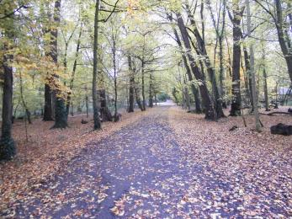
Woodland walk
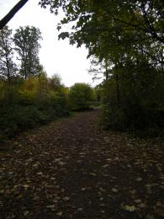
Woodland walk

Picnic Area

we have varied picnic areas
- From the car park to the picnic area, there is level access. The path is 850mm wide, or more.
- The entrance is 850mm wide.
- Some tables have space for wheelchair users. You can bring your own food to the picnic area.
- There are picnic tables available in several areas of the park however Barbequing is only allowed within certain areas. All picnic tables are accessable for wheelchairs and pushchairs.

Bird Hide
- From the main entrance to this area, there is level access. There is a permanent ramp. The route is 1180mm wide, or more. The entrance is 870mm wide.
- The Bird hide can be located in the park on the Red trail. There is an accessable ramp to the bird hide which has a boardwalk surface. There is level access inside the hide with seating. The Hide looks over the lake to the Heronry and Heron standing ground.

Top Pool Lodge Toilets
- From the main entrance to this area, there is level access. The route is 2mm wide, or more. The entrance is 850mm wide.
- The unisex accessable toilet is locked with a RADAR key. Addditional standard male and female toilets and a unisex baby change are also availble in this building.
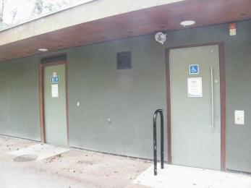
Top pool lodge toilets

Customer care support

Accessibility equipment
- We provide wheelchairs. There is a charge for wheelchairs.
- We have a hearing loop in A Hearing loop is available in the Information centre. and Wheelchairs are available on a deposit basis..
- The assistance toilet and baby change are approximate 150m from the information centre.

Emergency evacuation procedures
- We have emergency evacuation procedures for disabled visitors.
- The fire alarm has flashing lights.

Customer care support
- Some staff have disability awareness training.

Guide last updated: 18 January 2019

